

Thornton

12189 Pennsylvania Street

Thornton, CO 80241

303.469.8868

303.469.5254 fax

800.873.8707

***Anchorage***

4307 Arctic Boulevard

Anchorage, Alaska 99503

907.258.2155

907.258.6634 fax

800.873.8707 ext. 105

***Fairbanks***

475 Hall Street

Fairbanks, Alaska 99701

907.456.3116

907.456.3125 fax

800.873.8707 ext. 132

### **Mat-Su Service Center**

701 E. Parks Highway

Suite 203

Wasilla, Alaska 99654

907.373.5440

800.873.8707 ext. 109

[***www.analyticagroup.com***](http://www.analyticagroup.com)

A Wholly Owned Subsidiary of The Aleut Corporation

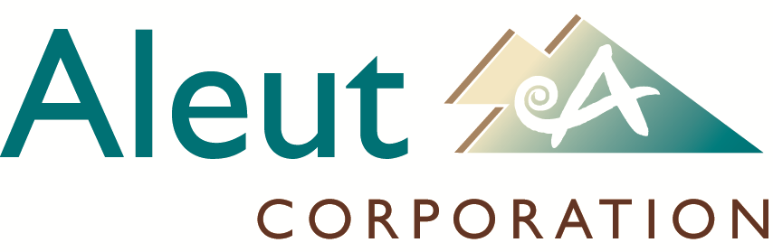

[***www.aleutcorp.com***](http://www.aleutcorp.com)

**Laboratory Analyst**

The Laboratory Analyst is responsible for producing consistent and accurate analytical data and technical reports. The Analyst operates and maintains laboratory equipment, instrumentation, and associated computerized reporting systems; prepares standards and QC samples to meet the required technical criteria; and is responsible for providing data that satisfy all appropriate QA/QC criteria and ethical considerations. The Analyst also assists with sample login, customer service, and additional tasks as needed. The Laboratory Analyst reports to the Laboratory Manager.

Tasks required of the Laboratory Analyst include:

1. Operate and perform routine maintenance of laboratory equipment and instrumentation. Maintain instrument and maintenance records and contact appropriate maintenance support services when needed.
2. Prepare standards, samples, and dilutions as appropriate to successfully conduct testing per Analytica’s Standard Operating Procedures (SOP).
3. Review data per all appropriate Quality Control (QC) and technical requirements. Alert the Project Manager and/or Laboratory Manager of any QC issues that could compromise data. Take proper corrective action when necessary.
4. Ensure data are accurately entered into LIMS. Provide comments, observations, and recommendations to properly report results to the customer. Generate and review the final report to ensure accuracy.
5. Maintain familiarity with applicable test methods and ensure all analyses are conducted in conformance with the methods and with Analytica’s SOPs. If any discrepancies are found, inform laboratory management and assist with updating SOPs.
6. Investigate and resolve sample login discrepancies.
7. Assist with resolving customer service issues as needed.
8. Conduct work in conformance with the Ethics Agreement specified by the laboratory. Report any observations of poor practice or unethical behavior, either intended or unintended, to the Laboratory Manager or Analytica’s Laboratory Operations Manager or General Manager.
9. Assist with proper sample and laboratory waste disposal according to appropriate regulations.
10. Perform any additional tasks as assigned by the Laboratory Manager.

**"Analytica...*Everything Else is Just Testing*"**